Use this website: <http://www.pyimagesearch.com/2015/10/26/how-to-install-opencv-3-on-raspbian-jessie/>

In step 3:

Note: for virtualenv and virtualenvwrapper, you don’t necessary need to install them. It’s just a virtual machine. I did not install them in my raspberry pi and it still works fine.

Ignore these words:

I’ve discussed both [virtualenv](https://virtualenv.pypa.io/en/latest/) and [virtualenvwrapper](https://virtualenvwrapper.readthedocs.org/en/latest/) many times on the PyImageSearch blog before, especially within these installation tutorials. Installing these packages is certainly not a requirement to get OpenCV and Python up and running on your Raspberry Pi, ***but I highly recommend that you install them!***

Using virtualenv  and virtualenvwrapper  allows you to create *isolated Python environments*, separate from your system install of Python. This means that you can run multiple versions of Python, with different versions of packages installed into each virtual environment — this solves the “Project A depends on version 1.x, but Project B needs 4.x” problem that often arises in software engineering.

Again, it’s standard practice in the Python community to use virtual environments, so I highly suggest that you start using them if you are not already:

Installing OpenCV 3 on Raspbian Jessie

Shell

|  |  |
| --- | --- |
| 1  2 | $ sudo pip install virtualenv virtualenvwrapper  $ sudo rm -rf ~/.cache/pip |

**Timing: 17s**

After virtualenv  and virtualenvwrapper  have been installed, we need to update our~/.profile  file and insert the following lines at the bottom of the file:

Installing OpenCV 3 on Raspbian Jessie

Shell

|  |  |
| --- | --- |
| 1  2  3 | # virtualenv and virtualenvwrapper  export WORKON_HOME=$HOME/.virtualenvs  source /usr/local/bin/virtualenvwrapper.sh |

You can use your favorite editor to edit this file, such as vim , emacs , nano , or any other graphical editor included in the Raspbian Jessie distribution. Again, all you need to do is open the file located at /home/pi/.profile  and insert the lines above at the bottom of the file.

Now that your ~/.profile  has been updated, you need to reload it so the changes can take affect. To force a reload of the ~/.profile  file you can (1) logout and log back in, (2) close your terminal and open up a new one, or (3) just use the source  command:

Installing OpenCV 3 on Raspbian Jessie

Shell

|  |  |
| --- | --- |
| 1 | $ source ~/.profile |

Note: You’ll likely need to run the source ~/.profile  command ***each*** time you open up a new terminal to ensure your environment has been setup correctly.

The next step is to create our Python virtual environment where we’ll be doing our computer vision work:

Installing OpenCV 3 on Raspbian Jessie

Shell

|  |  |
| --- | --- |
| 1 | $ mkvirtualenv cv |

The above command will create a virtual environment named cv  using ***Python 2.7***.

If you want ***Python 3***, run this command instead:

Installing OpenCV 3 on Raspbian Jessie

Shell

|  |  |
| --- | --- |
| 1 | $ mkvirtualenv cv -p python3 |

Again, it’s important to note that the cv  Python environment is ***entirely independent*** from the default version of Python included in the download of Raspbian Jesse.

If you ever reboot your system, logout and log back in, or open up a new terminal, you’ll need to use the workon  command to re-access the cv  virtual environment, otherwise you’ll be using the system version of Python instead:

Installing OpenCV 3 on Raspbian Jessie

Shell

|  |  |
| --- | --- |
| 1  2 | $ source ~/.profile  $ workon cv |

You can ensure you are in the cv  virtual environment by examining your command line. If you see the text *“(cv)”* preceding your prompt, then you***are***in the*cv*  virtual environment:

[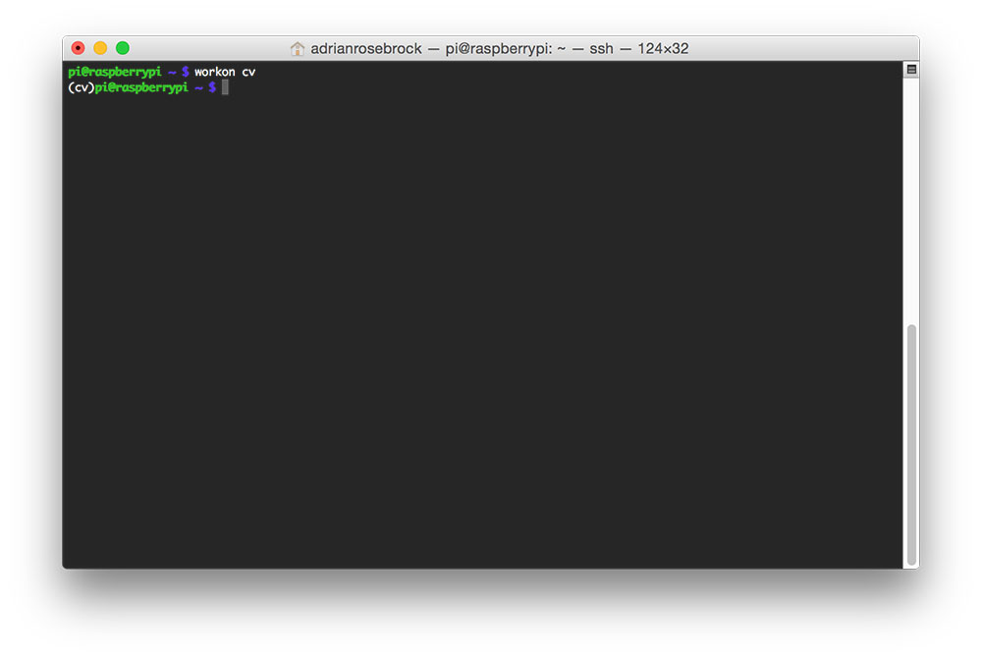](http://www.pyimagesearch.com/wp-content/uploads/2015/10/raspbian_jessie_accessed_env.jpg)

**Figure 1:** Make sure you see the “(cv)” text on your prompting, indicating that you ***are*** in the cv virtual environment.

Otherwise, *you****are not****in the cv  virtual environment:*

[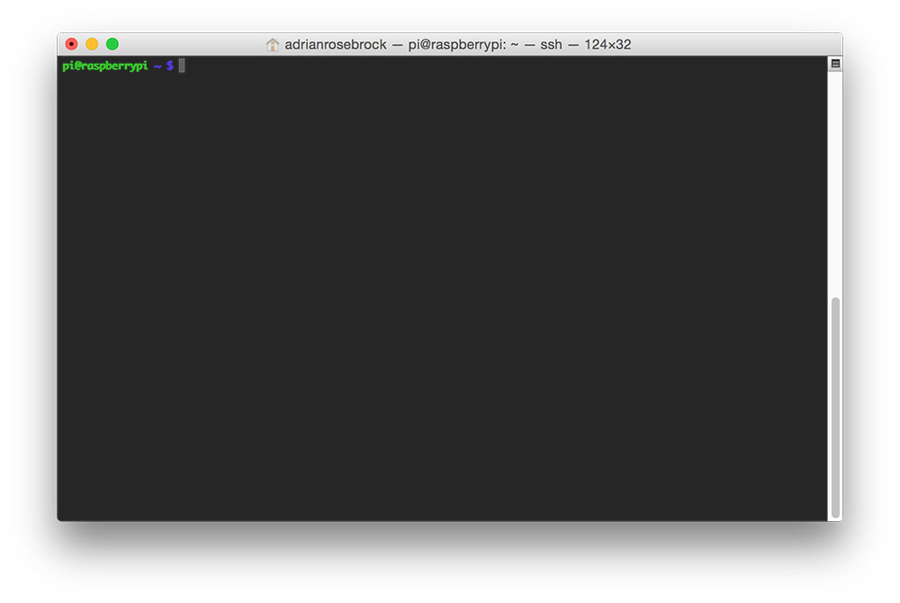](http://www.pyimagesearch.com/wp-content/uploads/2015/10/raspbian_jessie_no_env.jpg)

**Figure 2:** If you ***do not*** see the “(cv)” text on your prompt, then you ***are not*** in the cv virtual environment.

If this is the case, you need to run the source  and workon  commands above.

In step 4:

Also, ignore $ workon cv command before you run OpenCV, this is because we don’t have virtual machine as running environment.

When compile OpenCV, don’t use: $ make -j4.

Use: make. Instead.

Reason:-j4 is a flag for using 4 cores on CPU to compile. This is faster, but will cause some issue.

In step 5:

Ignore:

The last step here is to sym-link the OpenCV bindings into the cv  virtual environment:

Installing OpenCV 3 on Raspbian Jessie

Shell

|  |  |
| --- | --- |
| 1  2 | $ cd ~/.virtualenvs/cv/lib/python2.7/site-packages/  $ ln -s /usr/local/lib/python2.7/site-packages/cv2.so cv2.so |

Because we are not in virtual machine.